CS 152 Go Lab

Description:
In this lab we will be revisiting our Go program from earlier in the class. To do this you will need to navigate through your file system to retrieve it. We will also attempt to host these new projects on GitHub so that our changes are safely stored in the cloud. Finally, we will try to make it graphical.

Let’s Begin.

Step 1

To begin please navigate to your old Go program and open it up for editing.

If your code is not already inside a Java project you should create a new java project in your file system for the Go Assignment. You can do this using the Java Extension in VSCode or using the build in functionality of other editors. In VSCode you would do it by simply typing:
>Java: Create Java Project
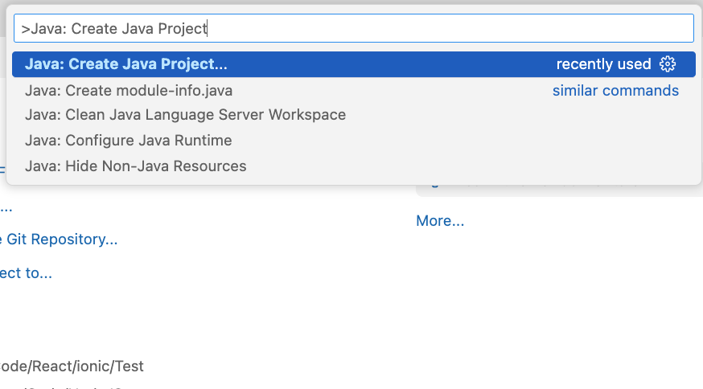

Step 2

Make sure that you are able to run your code. Either with the VSCode built in compile/run button or through the terminal. If you are using the terminal, you can use the following two commands:
<Note: Don’t copy the $ or anything in <>>

$ javac <your java filename>

$ java <your java classname (no .java)>

Step 3

Now if you have not accomplished this already, I would like you to extend the functionality of your java code so that it satisfies the previous requirements of the lab. More specifically that your code:

- Be able to place White and Black Pieces in turn.
- Detect out of bounds positions and overlap.
- Display a 9x9 go board with the crosshatch pattern.

Step 4

Finally, I’d like you to store this on your own GitHub account so that you can keep track of it as you contribute to it. First you need to create a new repository on your GitHub page. To do this simply navigate to your profile on GitHub and then the Repositories tab and select New.



Next you must upload your local files to this new repository. In order to do this you must run some git commands inside of your project. These commands are as follows:

$ git init
$ git add .
$ git commit -m “initial commit”
$ git branch -M main
$ git remote add origin <url to your git repo>
$ git push -u origin main

This git repository link will be what you submit for this lab.

If your commands are not working properly, you can also upload manually through the GitHub website.

Step 5 (Bonus Steps)

If your board is working in the terminal you can start translating some of this information into a GUI.

The first thing I’d recommend doing is creating a couple of variables for the styling of your board like so:

int GAP = 30;
int MARGIN = 10;

If you are placing these outside of your main method be sure to make them static.

Also, here are some imports we’ll use:

import javax.swing.*;
import java.awt.*;
import java.awt.event.*;

Within your main method (or a showUI function if you would like to get fancy) you should next add a frame and some behaviors. We’ll be using our variables from before:

JFrame frame = new JFrame("Go");
frame.setSize(GAP * board.length, (GAP+2) * board.length);
frame.setDefaultCloseOperation(JFrame.EXIT_ON_CLOSE);
//OPTIONAL: frame.getContentPane().setBackground(<You can Change color here>);

Finally, we are going to be working with Panel Painting within a new component that we will add to our Frame:

frame.add(new Component() {
public void paint(Graphics g) {

//TODO

}
});

frame.setVisible(true);

Inside this paint method we will paint the lines by using the margin and gap that we defined earlier. We will also paint the stones which I have defined as the “O” for white, “@” for black, and “null” for empty in the code on the next page.

Inside of this paint method I added the following code to paint lines and then any stone that may be present:

// Draw Board Lines
g.setColor(Color.BLACK);
for (int i = 0; i < board.length; i++) {
g.drawLine(MARGIN, MARGIN+i*GAP, MARGIN+(board.length-1)*GAP, MARGIN+i*GAP);
g.drawLine(MARGIN+i*GAP, MARGIN, MARGIN+i*GAP, MARGIN+(board.length-1) * GAP);
}

// Draw Stones
for (int x = 0; x < board.length; x++) {
for (int y = 0; y < board.length; y++) {
if (board[x][y] != null) {
g.setColor(board[x][y] == "@" ? Color.BLACK : Color.WHITE);
g.fillOval(MARGIN + x * GAP - 12, MARGIN + y * GAP - 12, 24, 24);
g.setColor(Color.BLACK);
g.drawOval(MARGIN + x * GAP - 12, MARGIN + y * GAP - 12, 24, 24);
}
}
}

It might be a good idea to test this with a directly initialized board like this:

String[][] board = {
{null, null, null, null, null, null, null, null, null},
{null, null, "O", "O", "O", null, null, null, null},
{null, null, "O", "@", "O", null, null, null, null},
{null, null, "O", "@", "O", null, null, null, null},
{null, null, null, "O", null, "@", null, null, null},
{null, null, null, null, null, "@", null, null, null},
{null, null, null, null, null, "@", null, null, null},
{null, null, null, null, null, "@", null, null, null},
{null, null, null, null, null, null, null, null, null},
};

Which should produce:

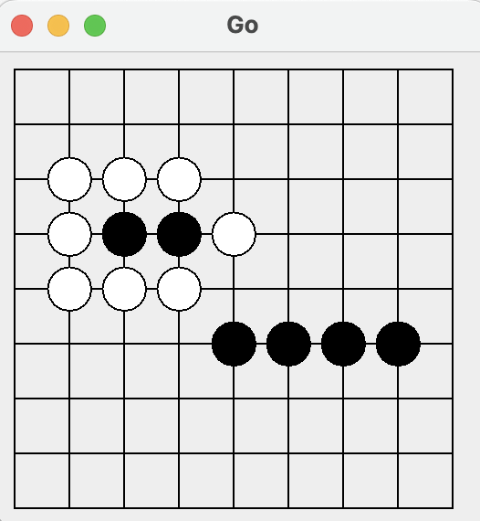

The cherry on top would be playing this with only the GUI and no terminal so to accomplish that you can add a listener to the mouse and see where it clicked. I won’t get too in the weeds on this code but see if you can figure out how its working. Paste this in above our frame.add(new Component() { line and put your board back to empty by default:

// Interaction logic
frame.addMouseListener(new MouseAdapter() {
public void mousePressed(MouseEvent e) {
// Adjust for window header which are called insets
int x = Math.round((float) (e.getX() - MARGIN) / GAP);
int y = Math.round((float) (e.getY() - MARGIN - frame.getInsets().top) / GAP);

if (x>=0 && x<board.length && y>=0 && y<board.length && board[x][y]==null) {
board[x][y] = blackTurn ? "@" : "O";
blackTurn = !blackTurn;
frame.repaint();
}
}
});

Try messing around with the code and make it your own, change the background color, change the board size, change the GAP, etc.

Happy Hacking!

